Spring AOP

Code for DAO

Public void addAcountId(Acount acc,String userId)

{

// add code for loggin code

// add code for security chcek

// get session

//session.save

}

New Requirement

Add Logging methods to DAO : loggiin stament before the strt of dao method

New Requirement

Add Security methods to DAO : make user is authorized before running of dao method

TPSreport?

If requiremrent to add to all layers

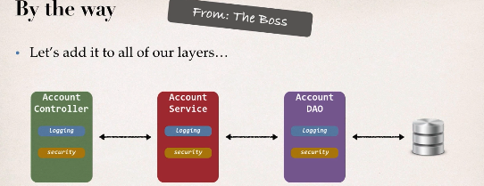

Two main problme

1 code tangling : fro given method logging and security will be tnagled

2 code scattering : need to change looging and security we need to update all classes (think 100 classes)

Other possible solutions

Inheritance: every class would need to inheri from a base class

Can all classs extend from base class ? plus no multiple inheritnace

Delegation : classes would delegete logging,security calls

- still would need to update classes if we wnated to

- add / remove logging or security

- add new feature like auditing,APi management, instrumentation

SOlution

AOP :Aspect

1 programming technique based on ASPECT

2 ASPECt encapsulet cross cutting logic :

**cross Cutting concerns :** means logic or functionlity : basic infrastructure that our all applicaion is required

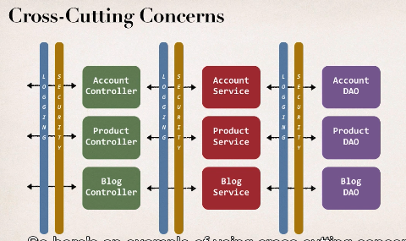

Common logic on respective layers

Aspect

1 can be reused at multiple loaction

2 same Aspect/class applied on base configuration

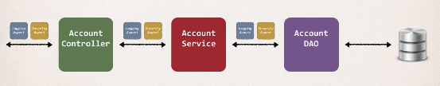

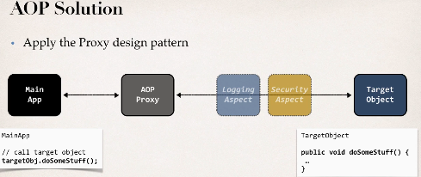

AOP proxy design pattern

- main app calls the target object

-method will be having some logic in target object

-Main app have no idea about AOP and no idea about any aspect behind secnce we dnt know its working will call just method

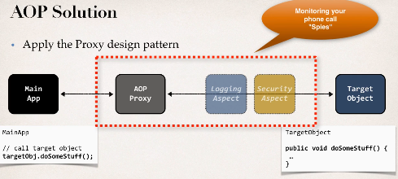

Befits of AOP

1 code for ASPECT is deisgned in a sinlge class

-much better then being scatrred every where

- Promtes code reuse and easier to change

2 Bussiness code in our application is cleaner

- only applies to bussiness funtionlity: addAccount

-reduce code complexity

3 Configurable

-based on configuration, apply aspects slectively to differt parts of app

-no need to make changes to main application code very important

Additonal use case

Most common: logging , security , tranaction

Audit loggin: who, what when ,where

Exception Handling:Log exception and notify DevOps team via SMS/email

API management:

-how many times has a method been called user

-analytics what are the peak times? Wt is Avg load ? who is top user

Advanteges and Disadvantages

Advantage: reusable modules, resolve code tangling, resolve code scatter, Applied slectively based on confiurtaion

Disadvantage: too many aspects and app flow is hard to follow, minor performance cost for aspect execution(run -tome -weaving)

Comparing SPringAOP and ASPECTJ

**AOP Terminology**

Aspect: module for code for a cross cutting concern(logging , security)

Advice: what actions should be taken and when it should applied

Join Point : when to apply code during program execution

Point Cut: A predict expression for where advice should be applied

**Advice Types**

Before Advice: run before method

After Finally Advice: run after the method (finally)

After returning Advice: run after the method (success excutio)

After Throwing Advice: run after method (if exception thrown)

Around Advice: run before and after method

**Weaving**

**-** connecting aspects to target objects to create an advice object

- differnet types of weaving : compile , run ,load -time

- regarding performance: run time weaving is the slowest,

AOP Frameworks

2 leading Framework SPRINGAOP and ASPECTJ

Spring AOP support

-key components: Security,tranaction ,cacheing etc

- uses run -time weaving aspects : usesr proxy pattern

ASPECTJ

- orinal AOP framwork relased in 2001

- provides compler suppport of AOP

- Rich support for AOP : Join points : method -level,constructor, field

Code weaing: compile time,post compile -time and laod time

SPRIGN AOPComparision

Spring AOP advanatage

- similat to use then ASPECTJ

- use proxy pattern

- can migrate to AspectJ when using @Aspect annotation

Disadvantage

- only support method level join points

- can apply to aspects to beans created by Spring app Context

- minor performance cost for aspect execution(run time weaving)

ASPECTJ Comparision

Advantages:

-Support all join points

-works with many pojo not just bean from app context

- faster compared to Spring AOP

- complet AOP support

Disadvantage

-Compile time waving requires extra compilation steps

- AspectJ pointCut syntax can become complex

Comparing Both

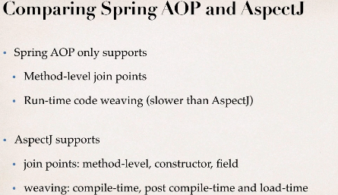

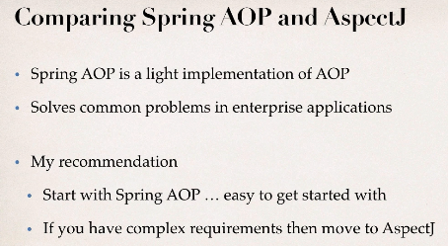

Road Map

1 create Aspect

2 Develop Advice

- before,After returning ,after throwing

-after finally , Around

3 create point cut expression

4 apply to cRM project

@Before Advice

Usecase:

Most commn:

logging ,security,transaction

Ex @Tranasctional works the same behind scecne called begin and end tranasction

Audit Logging: who,when where

API management

Adding AspetJ jar

Because Spring AOP uses some AspetJ annotaions, and classes

Develeopmetn process

1 createing target Object : ACCount DAO

2 creating simple java config file

3 create main app

4 create an aspect with @Before advice

Best practice of Advice and Aspects

-keep the code small and fast

-dnt perform any expensive or slow operations

- get in and out as sson as possible

Deveolpment

Create Java project add spring jars and aspectj weaver jar

1 @Component

**public** **class** AccountDAO {

**public** **void** addAccoount() {

System.***err***.println(getClass()+ " Doing DB work: addin in account");

}

}

2

// spring pure java configuration

@Configuration

@EnableAspectJAutoProxy //Sring can AOP objects for calling (Spring AOP proxy support)

@ComponentScan("com.spring.demoaop")

**public** **class** DemoConfig {

}

3

**public** **class** MainDemoApp {

**public** **static** **void** main(String[] args) {

//read sring java class

AnnotationConfigApplicationContext context= **new** AnnotationConfigApplicationContext(DemoConfig.**class**);

// get the beans form spring container

AccountDAO accountDAO=context.getBean("accountDAO",AccountDAO.**class**);

// call bussiness method

accountDAO.addAccoount();

System.***err***.println("lets call bussiness method again");

// lets call bussiness method again

accountDAO.addAccoount();

// clsoe context

context.close();

}

}

4

@Aspect

@Component

**public** **class** MyLoggingAspect {

// we had all related advices

// lets starts with @Before advice

// public void addAccoount() ==> point cut expression

// run this code BEFORE- tearget Object method "public void addAccoount()"

@Before("execution(public void addAccoount())")

**public** **void** beforeAddAccountAdvice() {

// custom code

System.***err***.println("=====> execuing @Before advice on addAccount()");

}

}

AOP terminology

1 pointcut: a predicate expression where advice shoul be applied

PointCUT Expression Language:

Spring AOP uses ASPECTJ pointcut expression language

- we will start with execution point cuts

-aaplies to execution methods

Match on Method name:

execution(modifers-pattern? Retrun-type-pattern declaring-type-pattern? Method-name-pattern(param-pattern) throws-patern?)

modifers-pattern: spring AOP only supprots public or *

Retrun-type-pattern: void,String ,boolean,etc..

declaring-type-pattern: class name

Method-name-pattern: method name/wild card option

Method-name-pattern(param-pattern): method with pararmeter type to match

throws-patern: exception type to match

? Is optional

Pattern can be wild cards for that we can use * (matches on everything)

Match on Method names

-match only addAccount() method in AccountDAO class

@Before(“execution(public void com.spring.demoaop.dao.AccountDAO.addAccoount())”)

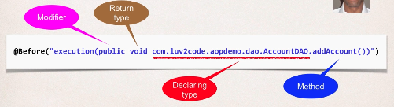

-match addAccount() method in any class

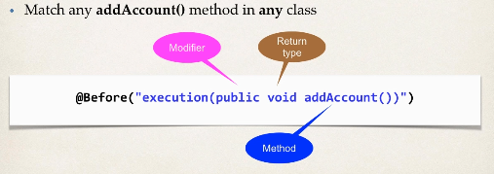

match on methods using wild cards

- match methods statrting with add any class

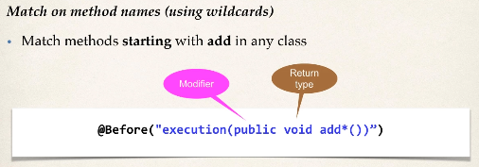

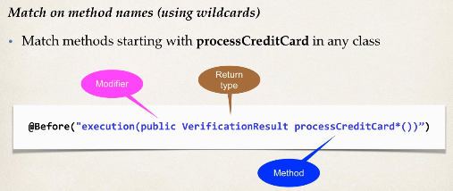

-use wild card entry on modifers and return type

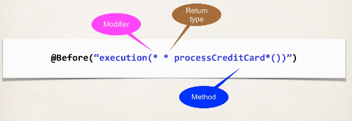

-modifiers optional



Match methos parameter types

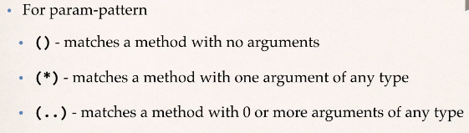

-match addAccount methods with no arguments

@Before("execution(* add*())")

match addAccount methods that have acouunt param

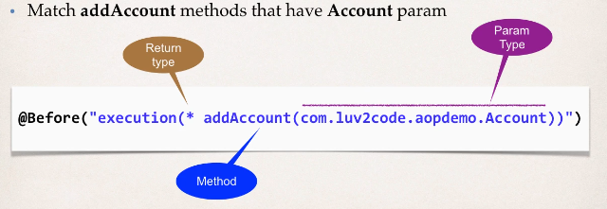

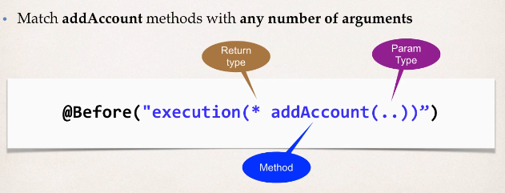

Match on Package

Match any method In DAO pacakge

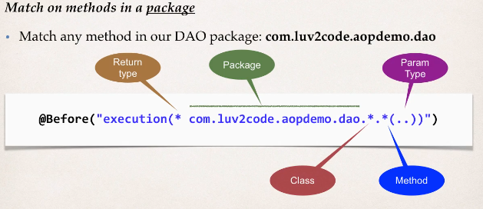

AOP pointcut Decalrations

Probelm

1 how can we reuse point cut expression

2 want to apply to multiple advices

@Before("execution(* com.spring.demoaop.dao.*.*(..))")

**public** **void** beforeAddAccountAdvice()

Solutions

- copy paste method

@Before("execution(* com.spring.demoaop.dao.*.*(..))")

**public** **void** beforeupdateAccountAdvice()

Ideal solution is

-create a point cut declaration once

- apply it to multiple advices

Development process

1 create a point cut declaration

2 apply point cut decalartion to advices

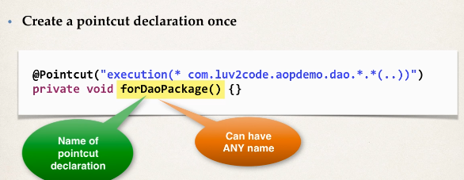

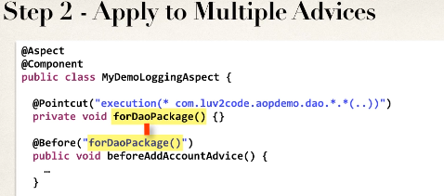

Benift

- easily reuse point cut expression

-update point cut in one loaction

-can combine point cut expression

1

// point cut decalartion

@Pointcut("execution(* com.spring.demoaop.dao.*.*(..))")

**private** **void** forDaoPackage() {}

2

@Before("forDaoPackage()") // point cut declaration and can be used in many advices commonly

**public** **void** beforeAddAccountAdvice() {

// custom code

System.***err***.println("=====> execuing @Before advice on addAccount()");

}

@Before("forDaoPackage()") // point cut declaration and can be used in many advices commonly

**public** **void** applyAPIAnalytics() {

// custom code

System.***err***.println("=====> performing API analytics");

}

1 How to apply multiple pointcut expression to a single advice

2 exceute advice if certain condtions met

Ex : all methods in package expt Getter Setter

Solution Combine Point cut Expression

* Combine point cut expression using logic operateors && , || , !
* Works like if stament execution evaluate only if it evaluate true

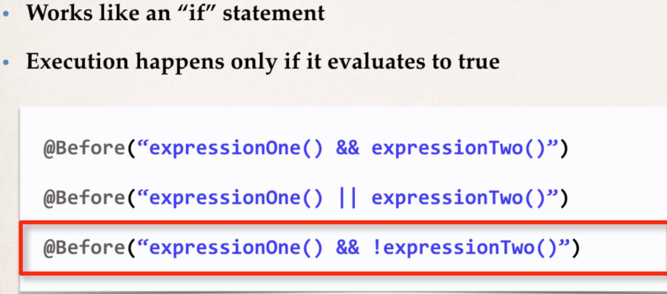

All methods expt getter and setter

Deveolpment process

1 create point decalartion

2 combine point cut decalartion

3 apply point cut decalartion to advices

1

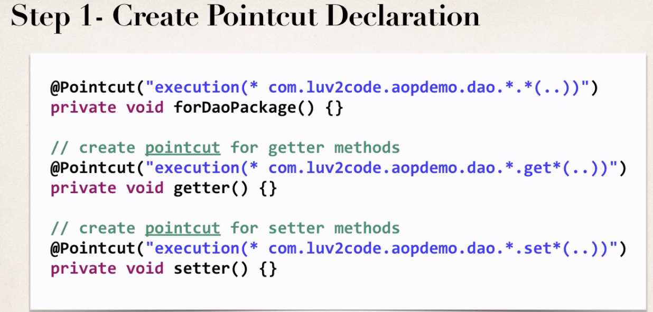

2

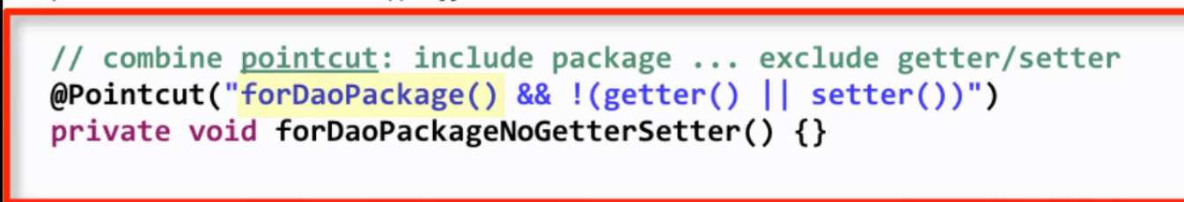

3

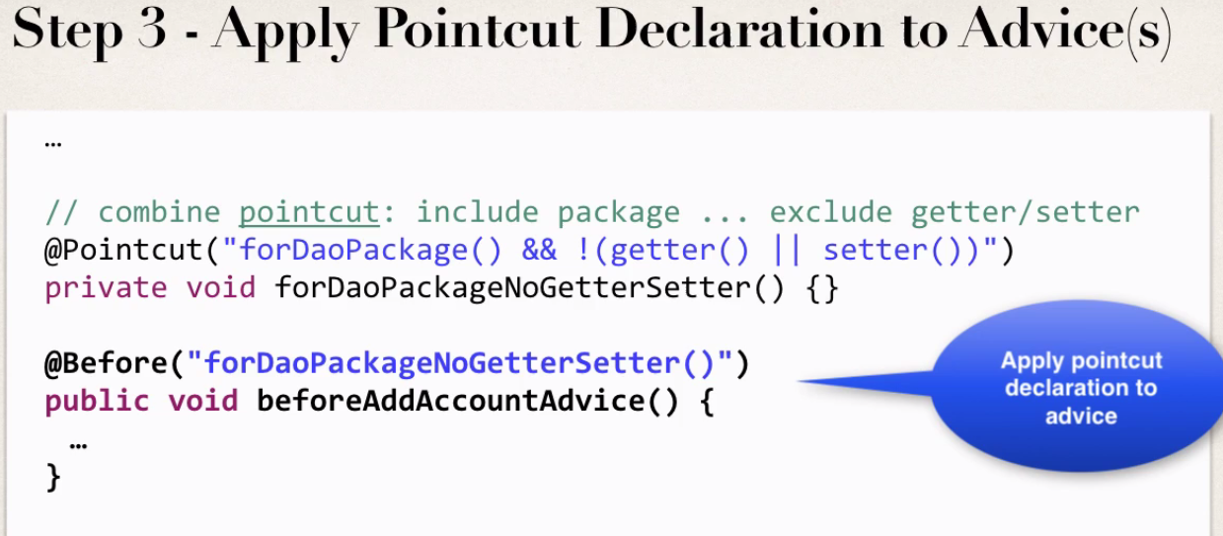

Aspect Order

How to control order of Advice when all match on same condition

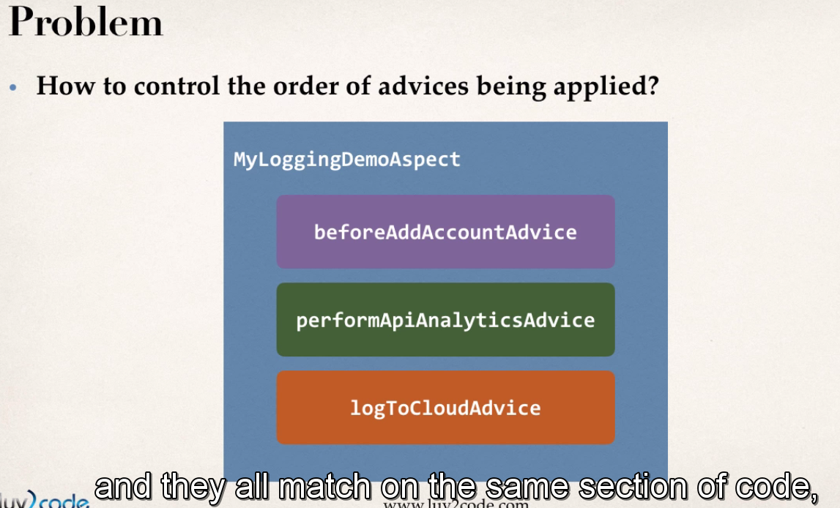

If all 3 advice matches there is no order they will run one by one order undefined

To Control Order

Refactor : place advice in Separate Aspects

Control Order on aspect using @Order

Garentee order when aspeccts are applied

Deveoplment process

1 refactor : place advice in separate aspect

2 add @Order to aspects

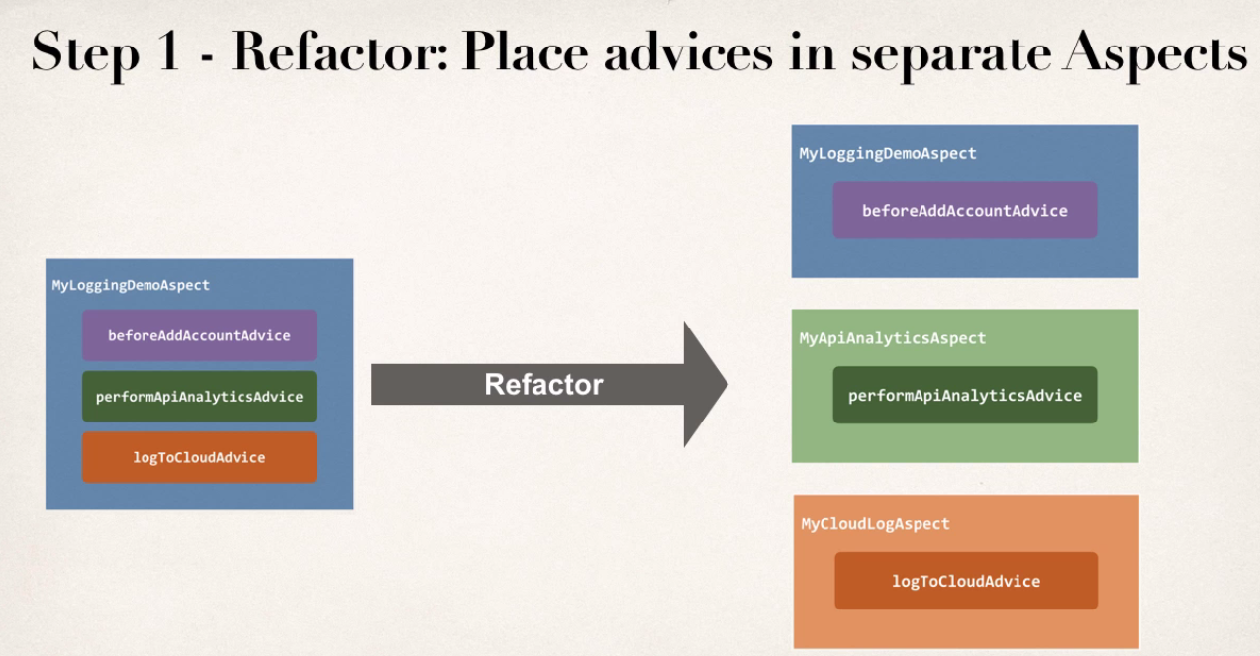

2

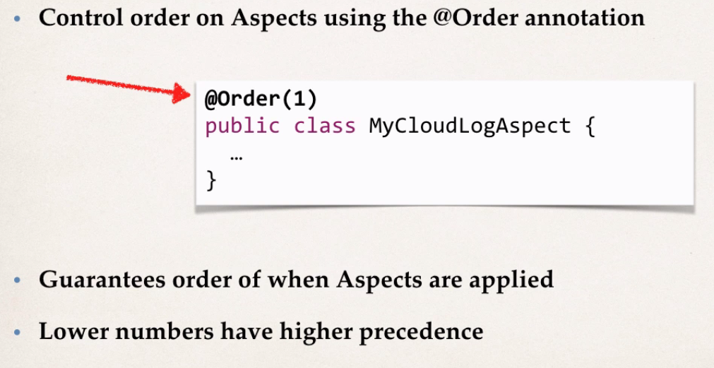

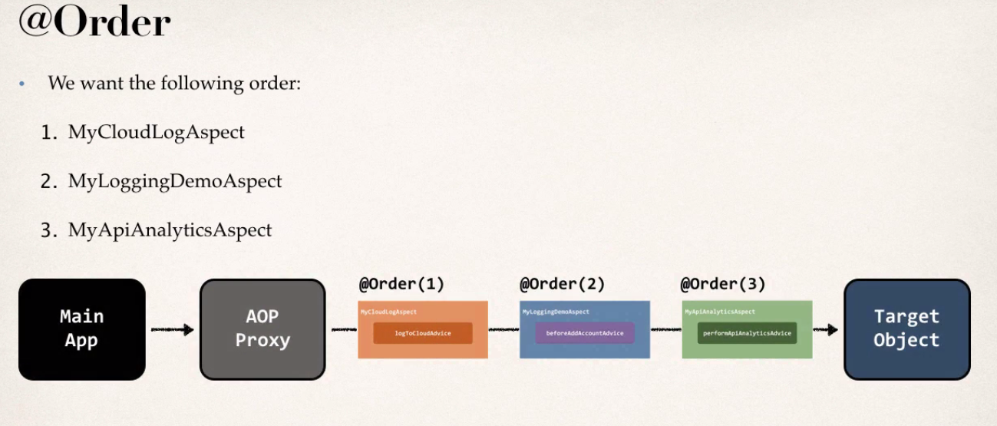

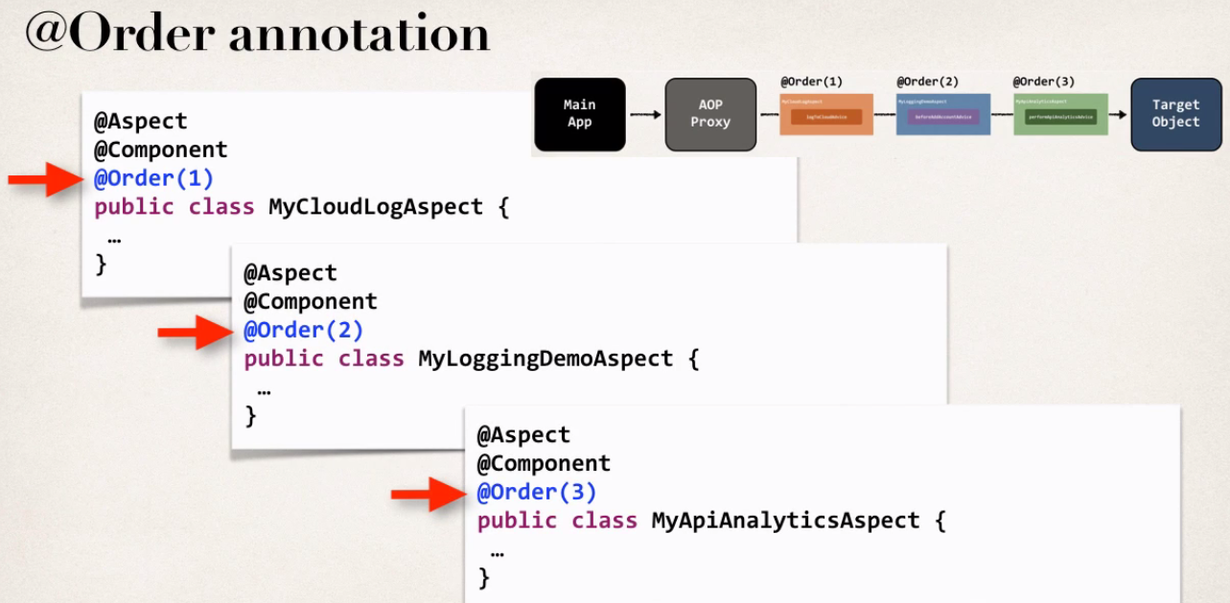

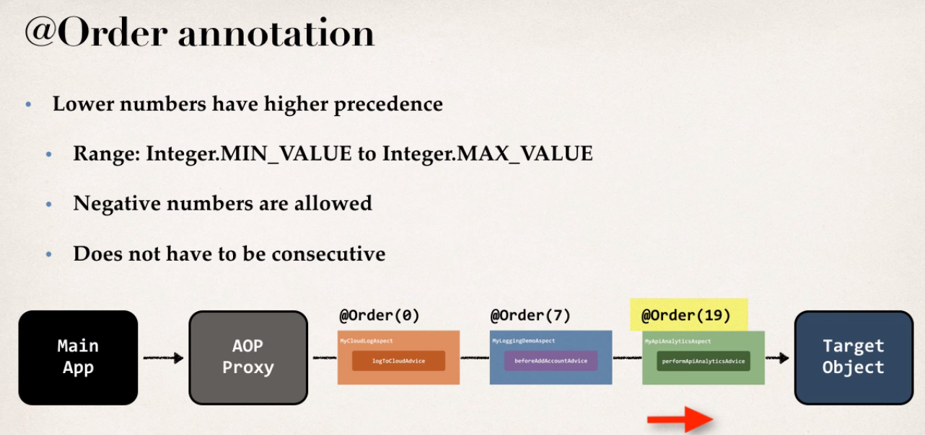

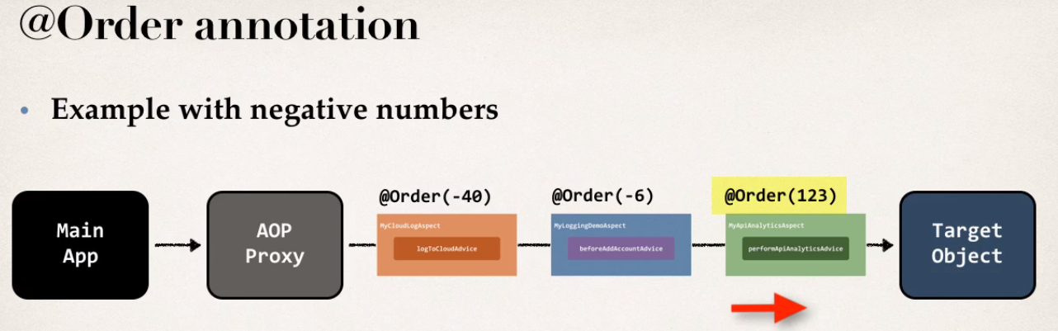

Wt if aspects have the exact same @Order

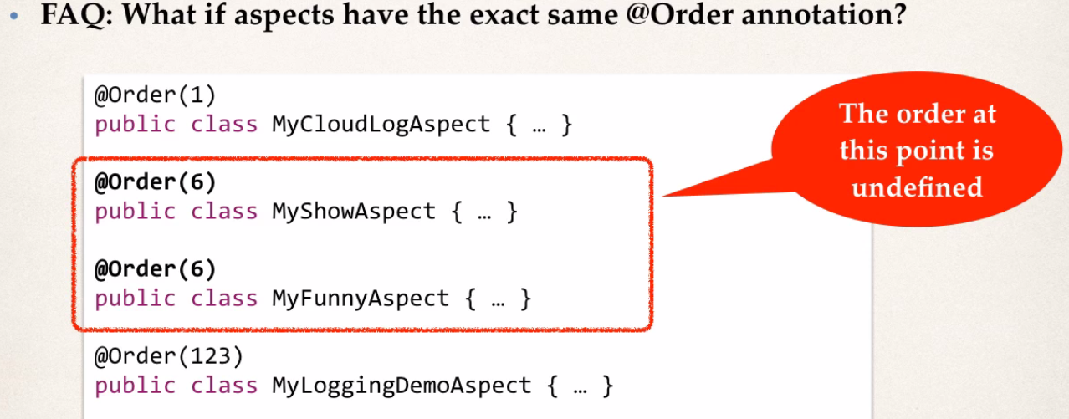

That time they two run seentially before and after of order aspects

Read method argemnts with JoinPoints

Peoblem: when we are in an aspect ie logging how can we access method parametrs

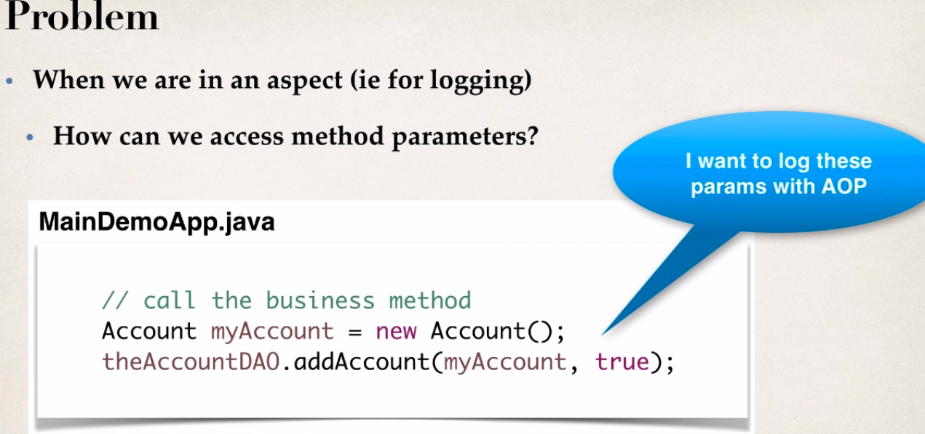

Developemnt process

1 Access and display method signature

2 access and display method arguments

1

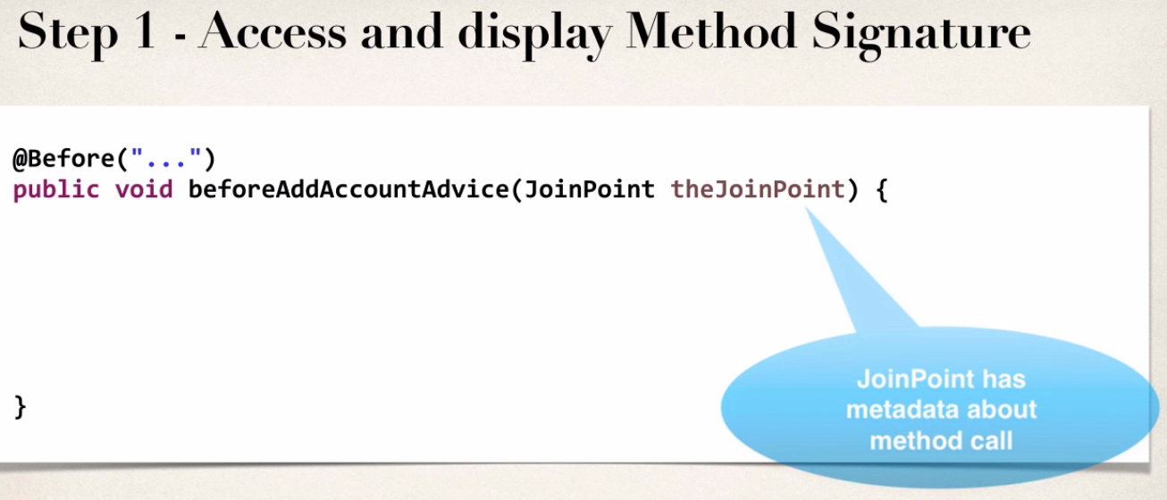

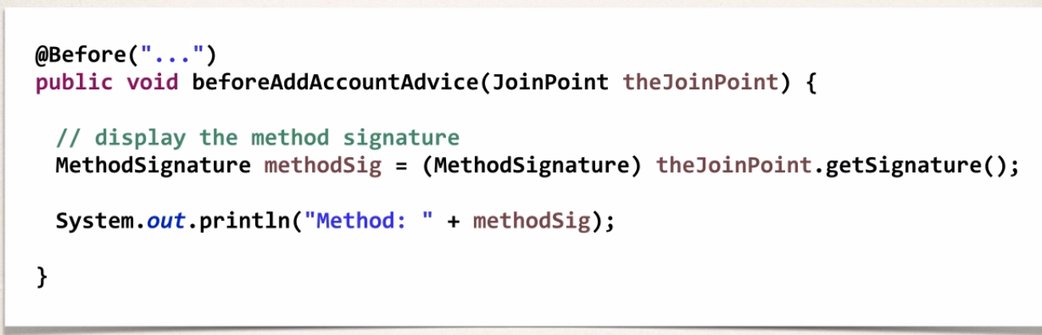

JoinPoint has meta data using this we can get method signature

2

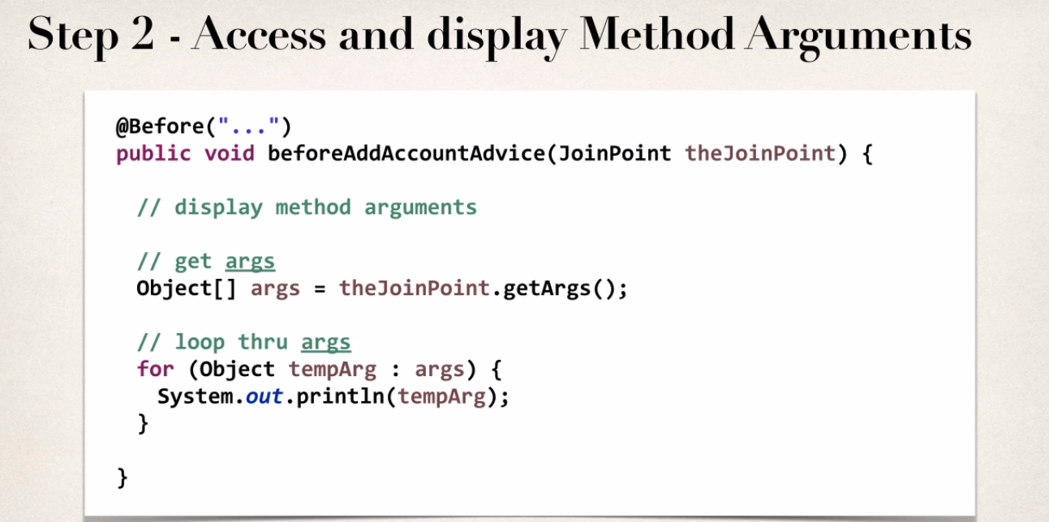

Adding new Advice and using point decalartion itself

@AfterReturning Advice

- run after the method success execution

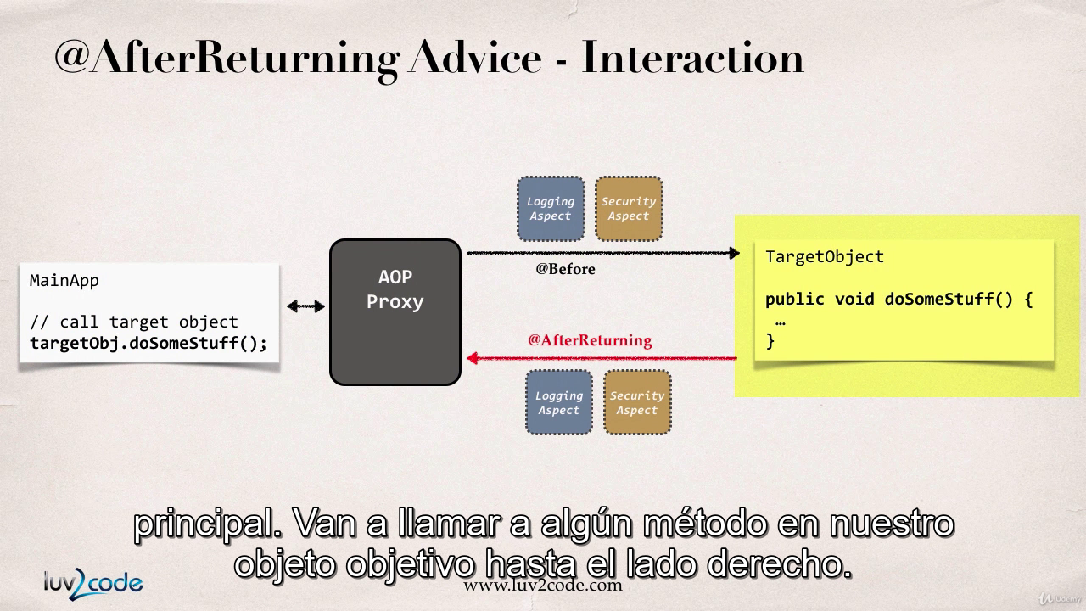

USE CASE

Common Use Case

-logging,Secuity,Transaction

Audit

-Who,where,when,what

Post Processing Data

-Post process the data before returning to caller

- Format data or enrich the data but carefully

Example

-Create an advice that will run after the method call after success execution

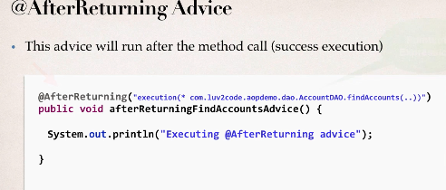

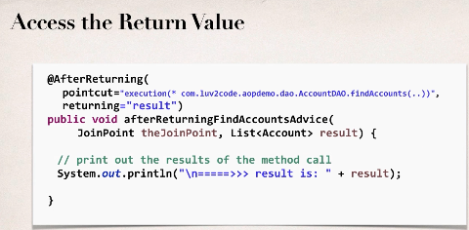

Development Process

1 Add Constrctour to Account Class

2 Add new Mthod findAccounts() in AccountDao

3 Update Main App to call new Method

4 Add @AfterReturning advice

4 @Aspect

@Component

@Order(2)

public class MyLoggingAspectAfterReturn {

// Add new Advie for @AfterReturning

@AfterReturning(pointcut="execution(* com.spring.demoaop.dao.AccountDAO.findAccounts(..))", returning="result")

public void afterReturnMethodAop(JoinPoint joinPoint , List<Account> result)

{

// print method we are advising

String method=joinPoint.getSignature().toShortString();

System.err.println(">>>@after retun method"+ method);

System.err.println(">>>@after retun result"+ result);

}

}

Post Processing Data before it returns

@AfterReturning to modify data

Like adding standard formate to company

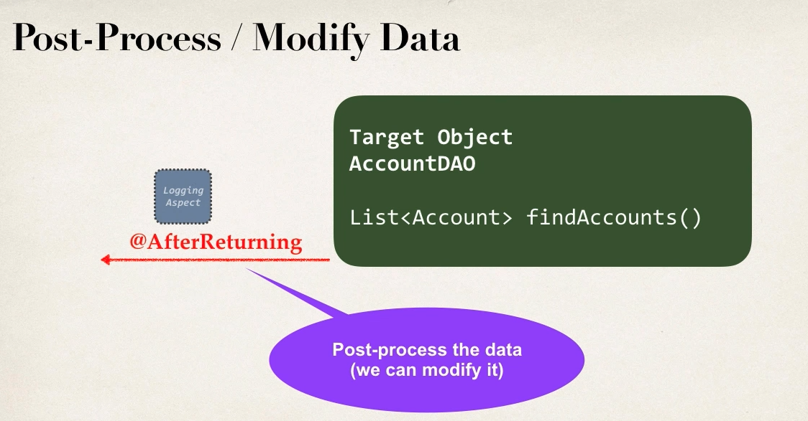

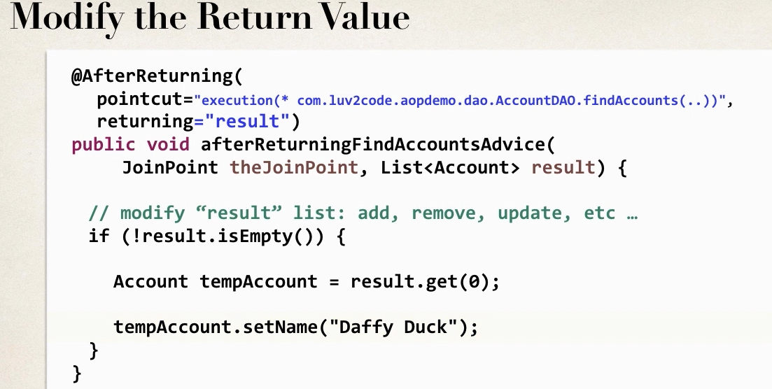

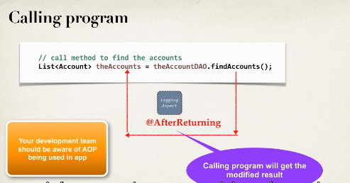

@AfterThrowing : it run after method throws an error

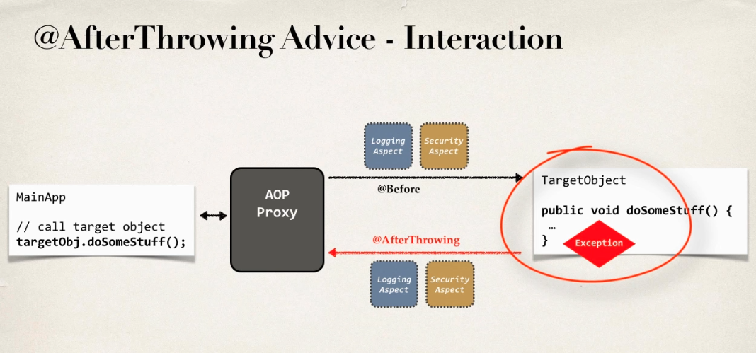

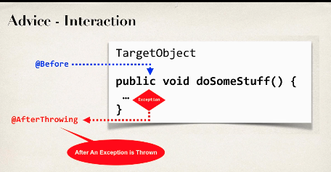

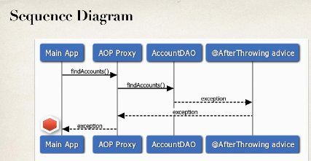

Use Cases:

Log the exception

Perform audtion on exception

Notify Devops Team via mail r sms

Encapsulate the functionlity in AOP aspect for easy reuse

Example

- create an advice that will run after an exception thrown

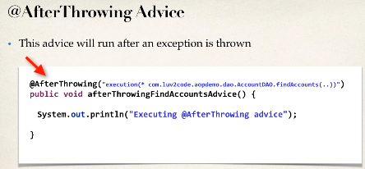

To access the Exception in Application side

Access the exception object

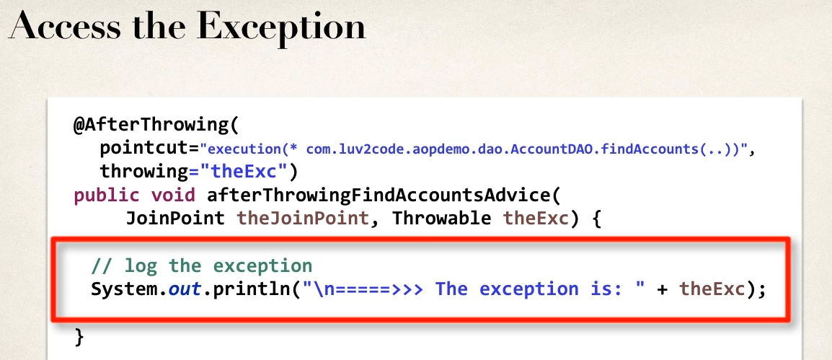

Exception Propagation

- only intercepting the exception

- exception is still propgated in calling program

To stop the exception propagation

-use @Around advice

Development Process

1 Main app add try n catch block for handling exception part

2 Modify AccountDAo to simulate throwing Excpetion

3 Add @AfterThrowing advice

@After Advice

- run after the method finally

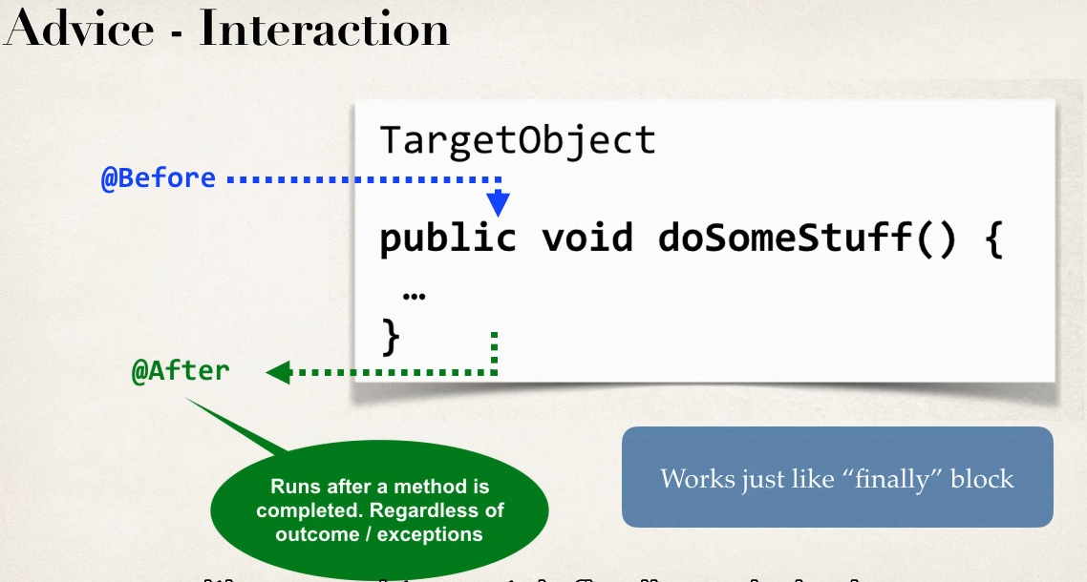

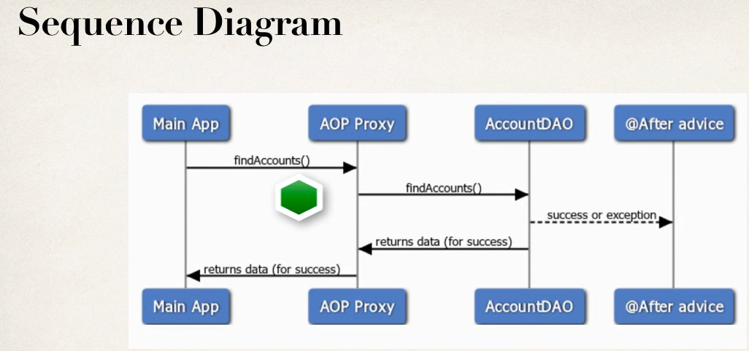

@After will run for success or failure (finally)

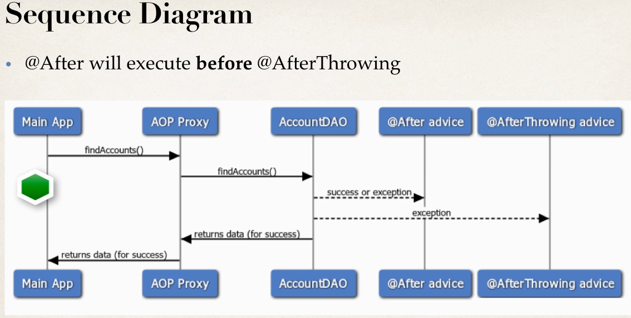

- log the exception / auditing

- code run regardless of method outcome

- encapsulate ths fucntionlityin AOP aspect for easy reuse

Example

- create a advice to run after the method( finally sucess / failure)

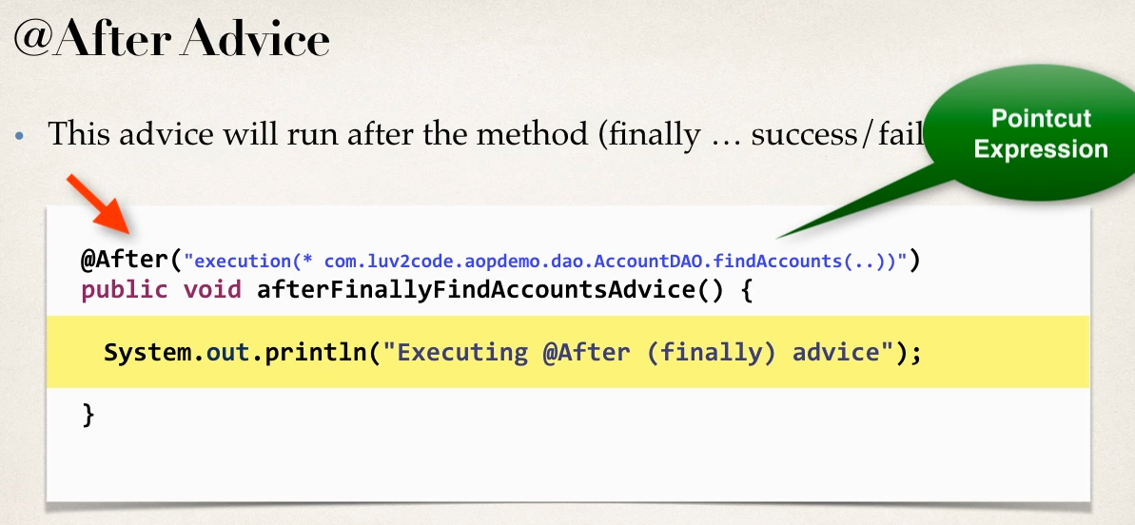

-@After advice doesnt have access to the exception

- if exception required use @AfterThrown

- @after should be able to sun in both cases

-logging is easy case here

Development Process

1 Prep Work

2 add @After advice

3 Task for failure /Exception case

4 task for success case

@AroundAdvice

- run before and after method

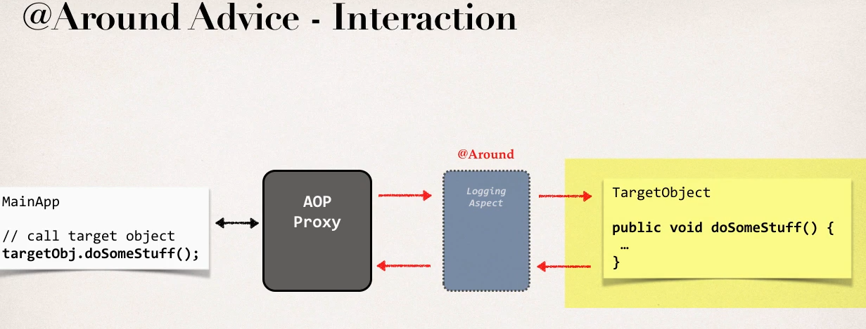

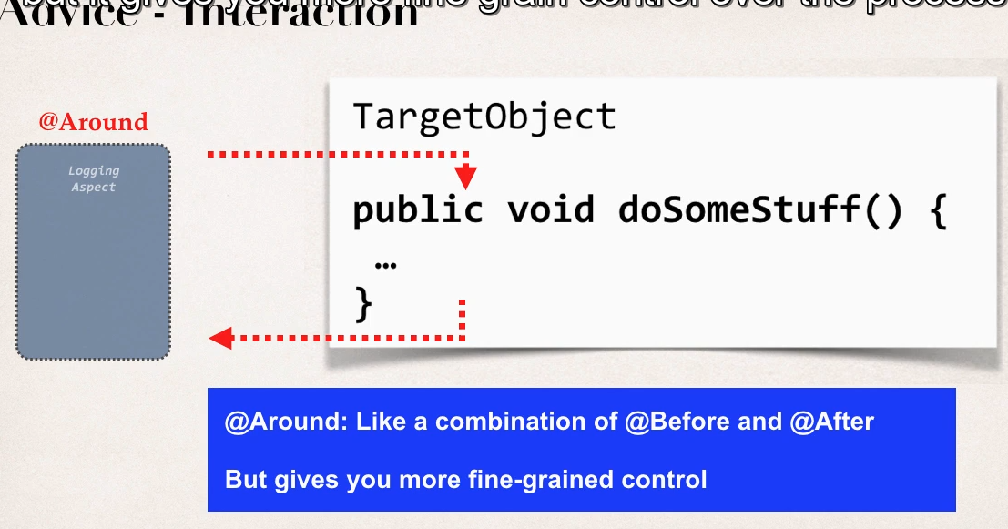

Use Case

- logging , auditing ,security

- Pre-processing and post -processing data

- instrumentation /profiling code

-- how long does it take for section of code to run ?

-Manage Excpetions

-- swallow /handle /stop exeptions

Example

With Fortune Service

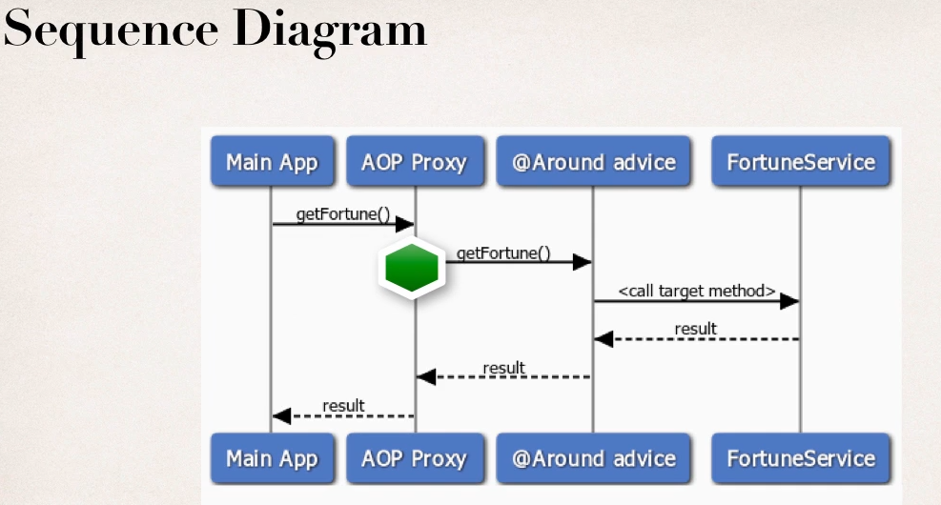

- using @Around Advice will get reference to a “proceeding join point” this the handle to the target method

- In code we can use proceeding join point to execute target method

Example :

- Create an advice for instrumentaion /profiling code

--how long does it take for a section of code to run

- theProceedingJoinPoint is to handle the target method

-- theProceedingJoinPoint .proceed() :-> execute the target method and method will return an object

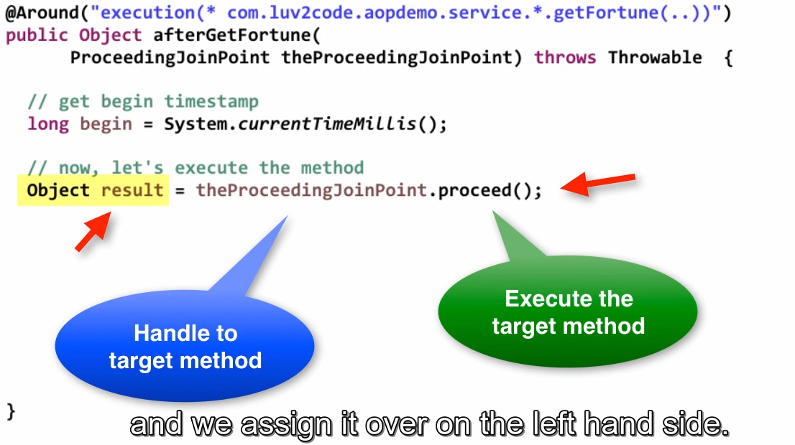

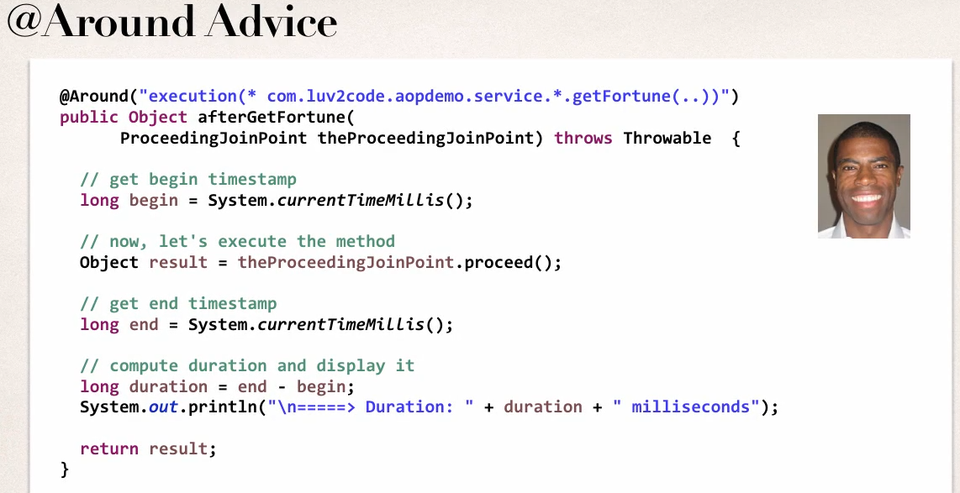

Development Process

1 Prep Work

2 Create TrafficFortuneService

3 Update main app to call TrafficFortuneService

2 Add @Around advice

Resolving Print Order Issues

-Root Cause

1 the data is printing to diff o/p streams

A )spring is printing to the logger output streams

B )System.out.println is something to the standard out output stream

-Solution

1. To have everything in order , you should send the same output stream
2. We’ll change code to use logger output stream same as spring

Development Process

1 Add a DemoClass to get Logger

2 AdviceAcpect class also add Logger

@Around advice Handling Exception

- for an exception thrown from ProceedingJoinPoint

--you can handle / swallow/ stop exception

-- or simply rethrow the exception

-- give fine control over how target method is called

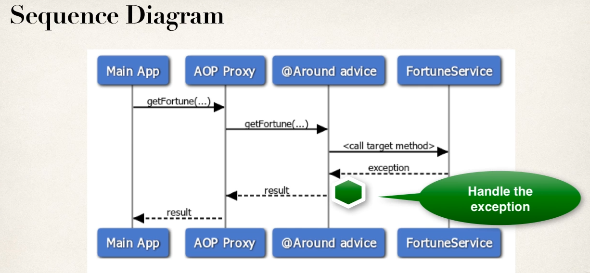

- key point is that when ever exception came we handle it in the @around advice and we log the excpetion in this stage

- assign default value to main program

Example of Handle Exception

Development Process

1 Prep Work

2 Add trip wire to simulate an exception

3 modify @Around to handle exception

@Around advice to re throw the Exception

